Software Design Document

for

PAD Database

Version 1.3

Prepared by Zachary Blue

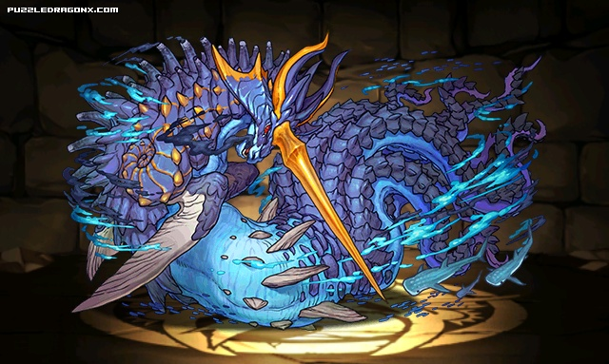McKenzie College

05/16/2017

# Change History

|  |  |  |  |
| --- | --- | --- | --- |
| **Name** | **Date** | **Reason for Changes** | **Version** |
| Zachary Blue | 05/11/17 | Initial scribing | 1.0 |
| Zachary Blue | 05/12/17 | Added new sections and added a context diagram | 1.1 |
| Zachary Blue | 05/15/17 | Added 2 diagrams and added to some empty fields | 1.2 |
| Zachary Blue | 05/16/17 | Added tables and list of figures | 1.3 |
|  |  |  |  |

# Table of Contents

Change History 2

Table of Contents 3

List of Figures 4

1. Introduction 5

1.1 Purpose 5

1.2 Scope 5

1.3 Context 5

1.4 Summary 6

2. References 6

3. Definitions, Acronyms, and Abbreviations 6

4. Body 7

4.1 Design Stakeholders and their concerns 7

4.1.1 Stakeholders 7

4.1.2 Concerns 7

4.2 Design Views 8

4.2.1 Collecting User Data 8

4.3 Design Viewpoints 8

4.3.1 User Data Collection 8

4.3.2 Database Maintainability 8

4.4 Design Elements 8

4.5 Design Overlays 8

4.6 Design Rationale 10

4.7 Design Languages 10

4.8 Structural Viewpoints 10

4.8.1 Active Skill Table 10

4.8.2 Attribute Table 10

4.8.3 AwokenSkill Table 10

4.8.4 AwokenSkillList Table 10

4.8.5 Badge Table 11

4.8.6 EvolutionTree Table 11

4.8.7 LatentSkill Table 11

4.8.8 LatentSkillList Table 11

4.8.9 LeaderSkill Table 11

4.8.10 MonsterClass Table 11

4.8.11 MonsterInstance Table 12

4.8.12 MonsterType Table 13

4.8.13 Player Table 13

4.8.14 Team Table 13

# List of Figures

Figure 1 Context diagram 5

Figure 2 Data Collection 8

Figure 3 DB Table design 9

# Introduction

## Purpose

This document serves as a baseline for designing our Puzzle & Dragons database and is intended for viewing by administrators, sponsors, and developers.

## Scope

The PAD DB is a tool for players of the game made in order to give them information on the monsters and allow them to simulate in game mechanics.

## Context

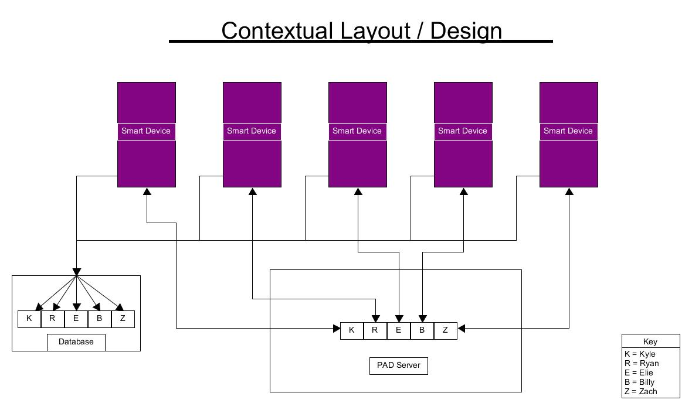The PAD DB is designed and made for the players of the Puzzle and Dragons mobile videogame and will store all information that is found within the North American version of the game as well as store data collected from the users of the DB.

#### Figure 1 Context diagram

## Summary

Our database will collect and store information provided by users and the game itself. We will allow users the opportunity to simulate actions performed within the game as well as allow them to view other DB user’s teams and even look for desired monsters for their collection.

# References

* The SRS that goes along with this document - [PAD DB srs.docx](PAD%20DB%20SRS%20new.docx)
* The source for the template of this document - [IEEE SDD 1016-2009](../../Downloads/SDD%20ieee%201016-2009.pdf)

# Definitions, Acronyms, and Abbreviations

PAD – Puzzle and Dragons

Monster – A creature that may be placed upon a team in PAD

Attribute – The element(s) that a monster can attack with

Type – A characteristic of each monster that determines their minimum stats

Active skill – An ability that a monster can perform in a dungeon that can affect a variety of different things within the dungeon including; the enemies, members of your team, and your health

Leader skill – An ability that is passive through the dungeon and is active based upon the leader of your team these effects include; adding base attack to your team, adding damage multipliers to your team, and reducing damage from monsters of certain attributes

Evolution – When a monster becomes a new better version of themselves

Experience – A key item that allows you to level up

Coins – A necessary item for leveling up and evolving monsters

Stamina – The most important thing every user has as it allows them to venture into dungeons

Pal points – Collected from helping friends in dungeons, using friends’ monsters in dungeons, and logging in each day

Egg machine – The place where a user can use magic stones or pal points to procure new monsters without entering a dungeon

Magic stones – A type of currency within PAD that allows the user to do many things including; restoring stamina, buying eggs from the egg machine, and allowing the user to continue a dungeon upon death (where applicable)

Dungeon – A section within PAD that allows the user to obtain experience, coins, magic stones, and monsters

Badge – A collectable item that gives a positive effect to a team while in a dungeon

Curve – The rate by which a monster gains Hp, ATK, and RCV while leveling

Monster Points – A currency which allows a user to purchase creatures for their inventory

Hp – Hit points

ATK – Attack

RCV – Recovery

DB – Database

NA – North America

PK – Primary Key

FK – Foreign Key

# Body

## Design Stakeholders and their concerns

### Stakeholders

* Users
* DB Admins
* DB Developers

### Concerns

* How will the user data be collected?
* Is this DB maintainable?

## Design Views

### Collecting User Data

#### Figure 2 Data Collection

## Design Viewpoints

### User Data Collection

User data will be collected in a series of steps pertaining to a legal method of collection of data from a player. A user shall input their own data into the DB and we shall take that and mold it into a viewable piece of information that is useful and informative to the user and any others that may find intrigue in facets of knowledge such as another user’s in game collection of monsters.

### Database Maintainability

This DB is maintainable and will be monitored by a specifically selected admin so that it may be kept up to date with all the latest PAD NA information.

## Design Elements

N/A

## Design Overlays

This database will contain 15 tables which are as follows;

*ActiveSkill:*

* A list of all current active skills found in the NA version of PAD

*Attribute:*

* Contains all 5 attributes used to attack in PAD

*AwokenSkill:*

* A list containing all currently available awoken skills in the NA version of PAD

*AwokenSkillList:*

* A list that contains every monster that has awoken skills’ awoken skills

*Badge:*

* The entire list of current badges and what they do for a team

*EvolutionTree:*

* A compiled list of the monsters that have evolutions and what those evolutions are

*LatentSkill:*

* A list of every currently available latent skill found in the NA version of PAD

*LatentSkillList:*

* A compiled list of user’s monsters and the latent skills they have

*LeaderSkill:*

* The list of all current leader skills found in the NA version of PAD

*MonsterClass:*

* The comprehensive list of all the monsters in the game along with their; skill (leader and active), ID, min/max stats, growth curves, min/max coin value, and various other information

*MonsterInstance:*

* A list of Individual players’ monsters and their current information

*MonsterType:*

* All the different types a monster can have currently

*Player:*

* A list of information about a player including their ID, and starting Attribute

*Team:*

* All the information about a team that a player has including the leader skill and all the monsters on the team

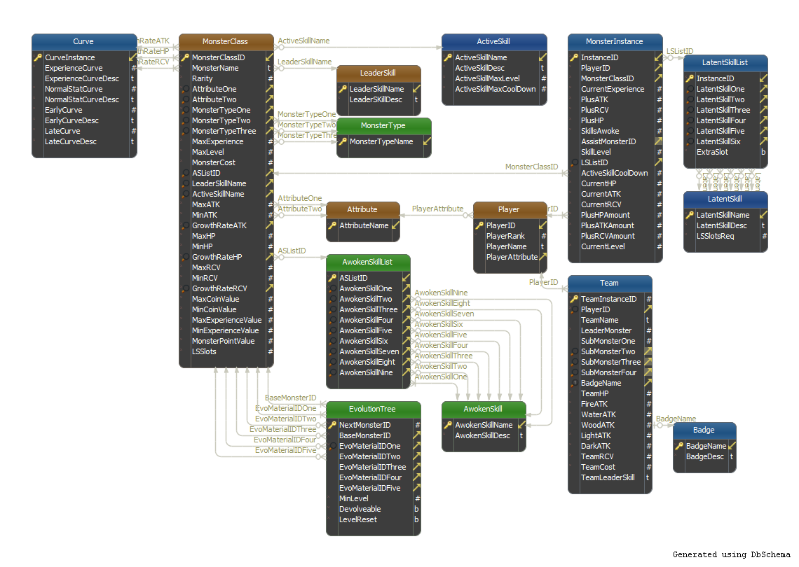

#### Figure 3 DB Table design

## Design Rationale

Our main idea here was to create a sustainable database that could be easily updated in the future when new additions to PAD are made.

## Design Languages

* Unified Modeling Language (UML) is used to create diagrams for this project
* DBSchema is used to design the tables for the DB

## Structural Viewpoints

### Active Skill Table

|  |  |  |  |  |
| --- | --- | --- | --- | --- |
| **Column Name** | **Properties** | **Key** | **Description** | **Relationship** |
| ActiveSkillName | VarChar (100) Not Null | PK | The name of the skill | N/A |
| ActiveSkillDesc | VarChar(Max) Not Null |  | What the skill does | N/A |
| ActiveSkillMaxLevel | Int Not Null |  | The highest reachable level for the skill | N/A |
| ActiveSkillMaxCoolDown | Int Not Null |  | The highest a skill’s cooldown can be | N/A |

### Attribute Table

|  |  |  |  |  |
| --- | --- | --- | --- | --- |
| **Column Name** | **Properties** | **Key** | **Description** | **Relationship** |
| AttributeName | VarChar (50) Not Null | PK | The name of the attribute | N/A |

### AwokenSkill Table

|  |  |  |  |  |
| --- | --- | --- | --- | --- |
| **Column Name** | **Properties** | **Key** | **Description** | **Relationship** |
| AwokenSkillName | VarChar (100) Not Null | PK | Name of awoken skill | N/A |
| AwokenSkillDesc | VarChar (Max) Not Null |  | What the skill does | N/A |

### AwokenSkillList Table

|  |  |  |  |  |
| --- | --- | --- | --- | --- |
| **Column Name** | **Properties** | **Key** | **Description** | **Relationship** |
| ASListID | Int | PK | ID pertaining to a monster on the list | N/A |
| AwokenSkillOne | VarChar (100) Not Null | FK | First awoken skill | AwokenSkill |
| AwokenSkillTwo | VarChar (100) | FK | Second awoken skill | AwokenSkill |
| AwokenSkillThree | VarChar (100) | FK | Third awoken skill | AwokenSkill |
| AwokenSkillFour | VarChar (100) | FK | Fourth awoken skill | AwokenSkill |
| AwokenSkillFive | VarChar (100) | FK | Fifth awoken skill | AwokenSkill |
| AwokenSkillSix | VarChar (100) | FK | Sixth awoken skill | AwokenSkill |
| AwokenSkillSeven | VarChar (100) | FK | Seventh awoken skill | AwokenSkill |
| AwokenSkillEight | VarChar (100) | FK | Eighth awoken skill | AwokenSkill |
| AwokenSkillNine | VarChar (100) | FK | Ninth awoken skill | AwokenSkill |

### Badge Table

|  |  |  |  |  |
| --- | --- | --- | --- | --- |
| **Column Name** | **Properties** | **Key** | **Description** | **Relationship** |
| BadgeName | VarChar (50) Not Null | PK | Name of the badge | N/A |
| BadgeDesc | VarChar (Max) Not Null |  | What the badge does | N/A |

### EvolutionTree Table

|  |  |  |  |  |
| --- | --- | --- | --- | --- |
| **Column Name** | **Properties** | **Key** | **Description** | **Relationship** |
| NextMonsterID | Int Not Null | PK | ID of the monster being evolved to | N/A |
| BaseMonsterID | Int Not Null | FK | ID of evolving monster | MonsterClass |
| EvoMaterialIDOne | Int Not Null | FK | ID of first material monster | MonsterClass |
| EvoMaterialIDTwo | Int | FK | ID of second material monster | MonsterClass |
| EvoMaterialIDThree | Int | FK | ID of third material monster | MonsterClass |
| EvoMaterialIDFour | Int | FK | ID of fourth material monster | MonsterClass |
| EvoMaterialIDFive | Int | FK | ID of fifth material monster | N/A |
| MinLevel | Int Not Null |  | Minimum level required to evolve | N/A |
| Devolveable | Bit Not Null |  | Is the monster devolveable | N/A |
| LevelReset | Bit Not Null |  | Is level reset upon evolution | N/A |

### LatentSkill Table

|  |  |  |  |  |
| --- | --- | --- | --- | --- |
| **Column Name** | **Properties** | **Key** | **Description** | **Relationship** |
| LatentSkillName | VarChar (50) Not Null | PK | Name of the latent skill | N/A |
| LatentSkillDesc | VarChar (Max) Not Null |  | What the skill does | N/A |
| LSSlotsReq | Int Not Null |  | How many slots does the skill take up | N/A |

### LatentSkillList Table

|  |  |  |  |  |
| --- | --- | --- | --- | --- |
| **Column Name** | **Properties** | **Key** | **Description** | **Relationship** |
| InstanceID | Int Not Null | PK | ID of the current instance | N/A |
| LatentSkillOne | VarChar (50) | FK | Name of first latent skill | LatentSkill |
| LatentSkillTwo | VarChar (50) | FK | Name of second latent skill | LatentSkill |
| LatentSkillThree | VarChar (50) | FK | Name of third latent skill | LatentSkill |
| LatentSkillFour | VarChar (50) | FK | Name of fourth latent skill | LatentSkill |
| LatentSkillFive | VarChar (50) | FK | Name of fifth latent skill | LatentSkill |
| LatentSkillSix | VarChar (50) | FK | Name of sixth latent skill | LatentSkill |
| ExtraSlot | Bit Not Null |  | Determines if there is an extra slot | N/A |

### LeaderSkill Table

|  |  |  |  |  |
| --- | --- | --- | --- | --- |
| **Column Name** | **Properties** | **Key** | **Description** | **Relationship** |
| LeaderSkillName | VarChar (100) Not Null | PK | Name of the skill | N/A |
| LeaderSkillDesc | VarChar (Max) Not Null |  | What the skill does | N/A |

### MonsterClass Table

|  |  |  |  |  |
| --- | --- | --- | --- | --- |
| **Column Name** | **Properties** | **Key** | **Description** | **Relationship** |
| MonsterClassID | Int Not Null | PK | Number ID for monsters in this table | N/A |
| MonsterName | VarChar (100) Not Null |  | Name of the monster | N/A |
| Rarity | Int Not Null |  | Number of a monster’s rarity | N/A |
| AttributeOne | VarChar (50) Not Null | FK | First attribute | Attribute |
| AttributeTwo | VarChar (50) | FK | Second attribute | Attribute |
| MonsterTypeOne | VarChar (50) Not Null | FK | First type | MonsterType |
| MonsterTypeTwo | VarChar (50) | FK | Second type | MonsterType |
| MonsterTypeThree | VarChar (50) | FK | Third type | MonsterType |
| MaxExperience | Int Not Null |  | Most experience a monster can have | N/A |
| MaxLevel | Int Not Null |  | Highest obtainable level | N/A |
| MonsterCost | Int Not Null |  | Cost to use on a team | N/A |
| ASListID | Int | FK | ID for the monster’s awoken skills | AwokenSkillList |
| LeaderSkillName | VarChar (100) | FK | Name of monster’s leader skill | LeaderSkill |
| ActiveSkillName | VarChar (100) | FK | Name of monster’s active skill | ActiveSkill |
| MaxATK | Int Not Null |  | Most ATK monster can have | N/A |
| MinATK | Int Not Null |  | Least ATK monster can have | N/A |
| GrowthRateATK | Int Not Null |  | How fast monster gets to highest ATK | N/A |
| MaxHP | Int Not Null |  | Most HP monster can have | N/A |
| MinHP | Int Not Null |  | Least HP monster can have | N/A |
| GrowthRateHP | Int Not Null |  | How fast monster gets to most HP | N/A |
| MaxRCV | Int Not Null |  | Most RCV monster can have | N/A |
| MinRCV | Int Not Null |  | Least RCV monster can have | N/A |
| GrowthRateRCV | Int Not Null |  | How fast monster gets to most RCV | N/A |
| MaxCoinValue | Int Not Null |  | Most coins the monster is worth | N/A |
| MinCoinValue | Int Not Null |  | Least coins the monster is worth | N/A |
| MaxExperienceValue | Int Not Null |  | Most experience the monster is worth | N/A |
| MinExperienceValue | Int Not Null |  | Least experience the monster is worth | N/A |
| MonsterPointValue | Int Not Null |  | Monster point value of the monster | N/A |
| LSSlots | Int Not Null |  | Latent skill slots the monster has | N/A |

### MonsterInstance Table

|  |  |  |  |  |
| --- | --- | --- | --- | --- |
| **Column Name** | **Properties** | **Key** | **Description** | **Relationship** |
| InstanceID | Int Not Null | PK | ID for current instance of table | N/A |
| PlayerID | Int Not Null | FK | ID of player that owns monster | Player |
| MonsterClassID | Int Not Null | FK | ID of monster | MonsterClass |
| CurrentExperience | Int Not Null |  | Monster’s current experience | N/A |
| PlusATK | Int Not Null |  | The extra ATK on monster | N/A |
| PlusRCV | Int Not Null |  | The extra RCV on monster | N/A |
| PlusHP | Int Not Null |  | The extra HP on monster | N/A |
| SkillsAwoke | Int Not Null |  | Amount of awoken skills monster has | N/A |
| AssistMonsterID | Int | FK | ID for monster assisting the monster | MonsterClass |
| Skilllevel | Int |  | Monster’s skill level | N/A |
| LSListID | Int | FK | ID for monster’s latent skills | LatentSkillList |
| ActiveSkillCoolDown | Int Not Null |  | Cooldown on monster’s active skill | N/A |
| CurrentHP | Int Not Null |  | Monster’s current HP | N/A |
| CurrentATK | Int Not Null |  | Monster’s current attack | N/A |
| CurrentRCV | Int Not Null |  | Monster’s Current RCV | N/A |
| PlusHPAmount | Int Not Null |  | The amount of HP monster has extra | N/A |
| PlusATKAmount | Int Not Null |  | The amount of ATK a monster has extra | N/A |
| PlusRCVAmount | Int Not Null |  | The amount of RCV a monster has extra | N/A |
| CurrentLevel | Int Not Null |  | Monster’s current level | N/A |

### MonsterType Table

|  |  |  |  |  |
| --- | --- | --- | --- | --- |
| **Column Name** | **Properties** | **Key** | **Description** | **Relationship** |
| MonsterTypeName | VarChar (50) | PK | Name of type | N/A |

### Player Table

|  |  |  |  |  |
| --- | --- | --- | --- | --- |
| **Column Name** | **Properties** | **Key** | **Description** | **Relationship** |
| PlayerID | Int Not Null | PK | ID of player | N/A |
| PlayerRank | Int Not Null |  | Player’s rank | N/A |
| PlayerName | VarChar (50) |  | Name of player | N/A |
| PlayerAttribute | VarChar (50) | FK | Player’s starting attribute | Attribute |

### Team Table

|  |  |  |  |  |
| --- | --- | --- | --- | --- |
| **Column Name** | **Properties** | **Key** | **Description** | **Relationship** |
| TeamInstanceID | Int Not Null | PK | ID of the current team instance | N/A |
| PlayerID | Int Not Null | FK | Player’s ID | Player |
| TeamName | VarChar (50) |  | Name of the team | N/A |
| LeaderMonster | Int Not Null |  | Name of leader monster | N/A |
| SubMonsterOne | Int | FK | Name of first sub monster | MonsterClass |
| SubMonsterTwo | Int | FK | Name of second sub monster | MonsterClass |
| SubMonsterThree | Int | FK | Name of third sub monster | MonsterClass |
| SubMonsterFour | Int | FK | Name of fourth sub monster | MonsterClass |
| BadgeName | VarChar (50) |  | Name of team badge | N/A |
| TeamHP | Int Not Null |  | Team’s HP | N/A |
| FireATK | Int Not Null |  | Team’s fire ATK | N/A |
| WaterATK | Int Not Null |  | Team’s water ATK | N/A |
| WoodATK | Int Not Null |  | Team’s wood ATK | N/A |
| LightATK | Int Not Null |  | Team’s light ATK | N/A |
| DarkATK | Int Not Null |  | Team’s dark ATK | N/A |
| TeamRCV | Int Not Null |  | Team’s RCV | N/A |
| TeamCost | Int Not Null |  | Team’s cost | N/A |
| TeamLeaderSkill | VarChar (100) |  | Team’s leader skill | N/A |